THE MODERN COMPUTER VISION PIPELINE
Technical Research Report
Submitted By
Muhammad Saqlain
BS Artificial Intelligence
The University of Faisalabad
Visibility Bots Innovation Lab
AI Summer Internship 2026
Track 1 – Computer Vision

1. Introduction
What is Computer Vision?
Computer Vision is a branch of Artificial Intelligence that enables computers to analyze, interpret, and understand digital images and videos. It combines image processing, machine learning, and deep learning techniques to solve visual problems automatically.
Today, Computer Vision is used in autonomous vehicles, healthcare, surveillance, agriculture, robotics, manufacturing, and many other industries. Modern Computer Vision systems follow a structured pipeline that transforms raw images into meaningful information for decision-making.

2. Computer Vision Pipeline
The pipeline is the heart of every Computer Vision system. Raw visual data flows through a series of stages — acquisition, preprocessing, feature extraction, detection, classification, segmentation, tracking, and deployment — each contributing to the overall performance of the system.
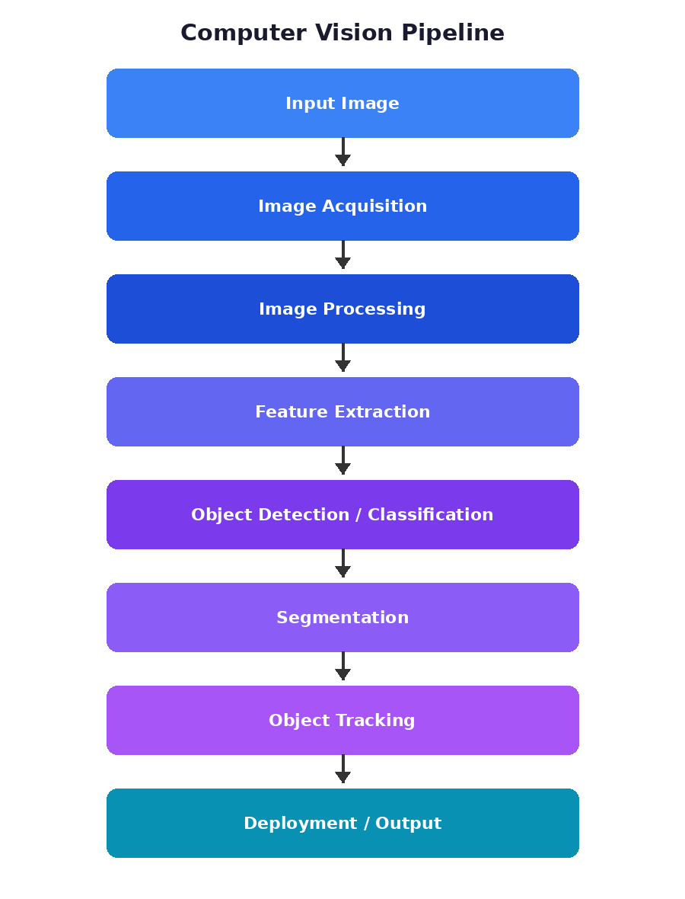
Figure 1: The Modern Computer Vision Pipeline

3. Image Acquisition
Image acquisition is the process of collecting images from different sources such as digital cameras, smartphones, CCTV cameras, webcams, drones, satellites, and medical scanners (CT, MRI, X-ray).
A high-quality input image is essential because poor lighting, motion blur, or low resolution can reduce the accuracy of later stages.
Example: A traffic camera continuously captures frames that are later analyzed to detect vehicles and traffic violations.

4. Image Processing
Image processing improves image quality before analysis. Common operations include resizing, grayscale conversion, noise removal, Gaussian and median blur, thresholding, contrast enhancement, and edge detection. These preprocessing steps reduce unwanted information while preserving useful details.

5. Feature Extraction
Feature extraction identifies the most important characteristics of an image. Traditional Computer Vision uses manually designed features such as SIFT, SURF, HOG, and ORB. Modern deep learning models automatically learn features using Convolutional Neural Networks (CNNs), resulting in higher accuracy on complex tasks.

6. Object Detection
Object detection identifies both what objects are present and where they are located within an image, typically drawing bounding boxes with confidence scores (e.g., Person 98%, Car 95%, Dog 93%).
Applications include autonomous driving, security surveillance, retail analytics, and smart cities. Popular algorithms include YOLO, SSD, and Faster R-CNN.

7. Image Classification
Classification predicts the overall category of an image (for example, an image of a cat is classified as ‘Cat’), without identifying object locations. Applications include medical diagnosis, plant disease identification, and product categorization.

8. Image Segmentation
Segmentation assigns a label to every pixel in an image. Types include semantic, instance, and panoptic segmentation. Applications include self-driving cars, medical imaging, and satellite image analysis, using popular models such as U-Net, SegNet, and Mask R-CNN.

9. Object Tracking
Object tracking follows an object's movement across multiple video frames. Applications include CCTV surveillance, sports analytics, traffic monitoring, and human activity recognition, using algorithms such as SORT, DeepSORT, and ByteTrack.

10. Deployment
After development, the Computer Vision system is deployed into a real environment such as desktop applications, mobile applications, cloud servers, edge devices, embedded systems, or industrial robots. A deployed model must be fast, reliable, and capable of handling real-world conditions.

11. Real-World Applications
Healthcare: disease diagnosis, tumor detection, X-ray analysis.
Agriculture: crop monitoring, disease detection, weed identification.
Transportation: autonomous vehicles, traffic monitoring, automatic license plate recognition.
Manufacturing: defect detection, quality inspection, robotic automation.
Security: face recognition, intrusion detection, crowd monitoring.

12. Conclusion
The modern Computer Vision pipeline combines image acquisition, preprocessing, feature extraction, object detection, classification, segmentation, tracking, and deployment to create intelligent systems capable of understanding visual data.
Advances in deep learning have significantly improved the accuracy and scalability of Computer Vision applications, making them an essential technology across healthcare, transportation, agriculture, manufacturing, and many other domains.

13. References
- Szeliski, R. Computer Vision: Algorithms and Applications.
- Kaehler, A. & Bradski, G. Learning OpenCV.
- OpenCV Documentation. https://docs.opencv.org
- Gonzalez, R. C. & Woods, R. E. Digital Image Processing.
- Relevant IEEE Computer Vision conference papers.

